SHRIMATI INDIRA GANDHI COLLEGE TRICHY

DEPARTMENT OF PHYSICS

NAAN MUDHALVAN PROJECT REPORT

Project partner: Smart internz

Project by: Data literacy with tableau

Class: III B.sc(physics)

Team NM ID: NM2023TMID04732

INTRODUCTION:

**OVERVIEW:**

In this report we have clearly picturize the world's top YouTube channels, their trends, their Countries, their Primary languages, and their Subscribers. Because YouTube has become a massive platform with billion of users Worldwide, who collectively watch more than one billion of hours of videos every day. This visualization gives the holistic insights about of the World's top YouTube channels. Through this analysis everyone can easily know even the minute details about the World's Top YouTube channels.

**PURPOSE:**

Masses always prefer visual over writing and audio. The huge number of creative people who want to do something prefer to exhibit their talents to the World through the YouTube channels. This result in the diverse range of videos on every topic. So we decided to do some analysis by exploring the World's Top YouTube Channels to pinpoint.

1. Top channels with their names

2. Channels with their native Countries

3. Their subscribers

4. Primary languages

5. Category wise channels

6. Language wise Subscribers

7. Country wise Subscribers

8. Channels with their overall Rank

**PROBLEM DEFINITION AND DESIGN THINKING:**

**EMPATHY MAP:**

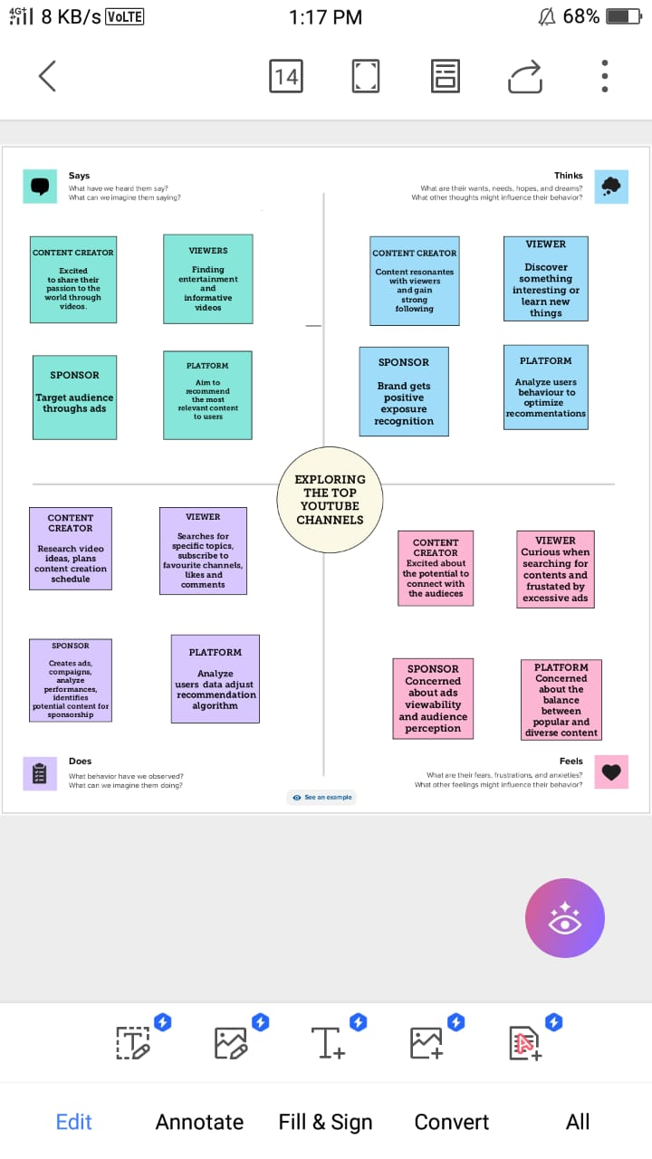

**BRAINSTROMING MAP:**

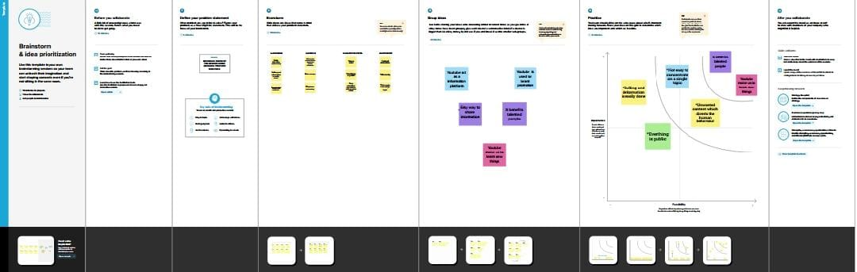

**RESULT:**

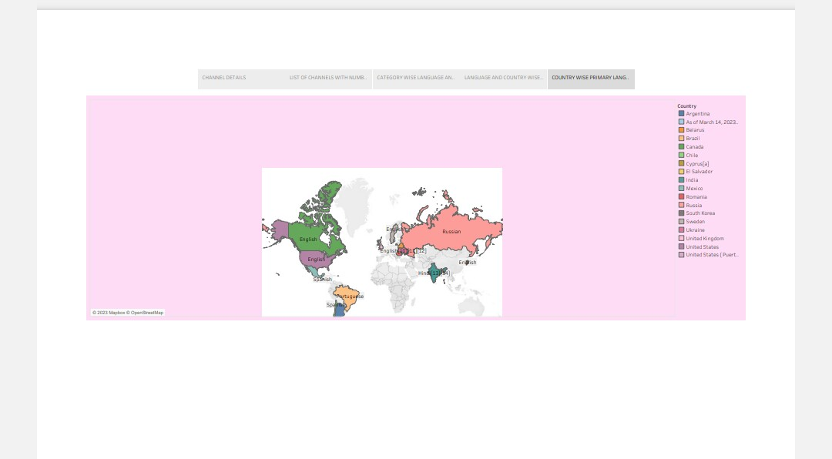

Through our Project analysis we conclude by clearly visualizing the country wise channels, their primary languages with its subscribers.

**ADVANTAGES:**

Gives access to huge video content.

* Gives opportunity to earn money through video.
* Facilitates to store video offline.
* Easy to use and share content with others.

Can be utilized for study purposes.

**DISADVANTAGES:**

* Some content has got paid access.
* A huge advertisement takes place.
* Some content is adult rated but still, the under-aged children can access it.
* There is no limit to view videos on YouTube.

Pirated videos still operate on YouTube.

**CONCLUSION:**

* From the above project analysis we conclude that YouTube channels have provide a lot of opportunities to learn, to explore new things, and allows us to share our creative ideas to everyone rather than its defects. By exploring the World’s Top YouTube channels we depict our analysis by showing the visualization of the top YouTube channels, their trends, and their subscribers.
* From this analysis everyone can easily correlate all the minute details along with picturization about the World’s Top YouTube channels.

**FUTURE SCOPE:**

* YouTube channels are now emerging as one of the best platform for creative minds to exhibit their creativity.After the post pandemic period everyone engage themselves with YouTube to use their time effectively.
* All students are receptive to video tutorial and one of the main benefits is that they can look the video again and again "WHENEVER THEY WANT, WHEREVER THEY WANT" to achieve their career objectives.
* In the upcoming years ,digitalization plays an important role. At that time YouTube become the source for anything and everything we want .So everyone try to start a YouTube channel to become an entrepreneur besides their career.
* At that point ,this analysis will be useful and it will guide them to craft their channels to achieve success by fulfilling their desires .

**APPENDIX**

Source code

https://public.tableau.com/app/profile/sreenidhi.s4307